
The walking School bus

A Walking School Bus – sometimes referred to as a Walk Pool – is when adult volunteers take turns leading a small group of neighborhood children to or from school. The watchful eye of an adult can provide a safer environment and allows children to reap the benefits of walking regularly.

A Walking School Bus has many benefits:
- It increases supervision, safety – and fun! – for students who already walk.
- It permits additional students to walk, introducing them to an important and easy habit.
- It reduces auto traffic, particularly near schools during drop-off and pick-up times.
- It creates a sense of community by getting neighbors to take turns as bus “drivers.”
5 steps to start a Walking School Bus
- Form a working group
Invite parents, students, the school principal, teachers and local businesses to explore options – routes, coordinators, resources, and sponsors.
- 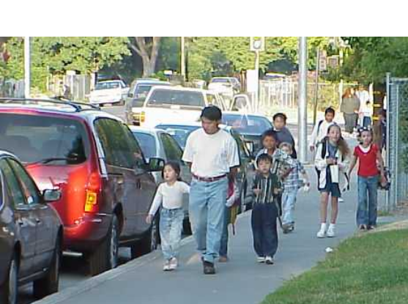Recruit walking school bus “drivers”
Ask neighbors and families of students to take a turn turn as a volunteer in the mornings or afternoons.
- Organize the walking school bus drivers
Work out a regular schedule among the drivers; determine who can walk with the students and when. Create back-up plans with substitute drivers.
- Designate walking school bus routes
Many parents already know how best to get around their neighborhood on foot, but in some instances routes may need to be mapped out. Work with the police department and the school to determine the safest routes.
- Promote the walking school bus
Once the drivers and routes are set, let everyone in the neighborhood know about the project. More walking school buses will create safer, healthier children and communities.
Adapted by CA Walk to School Day Headquarters from: National Highway and Transportation Safety Administration, June 2001
Visit our website for more ideas to promote safe routes to schools: http://www.cawalktoschool.com/
Download a guidebook to help you start a walking school bus: http://www.cdc.gov/nccdphp/dnpa/kidswalk/index.htm

